**Abstract:**

**Emotion can be expressed in ways that can be seen such as facial expression and gestures. Emotion can also be heard by detecting prosody features and other vocal characteristics. However in this research, we**

**are interested to detect emotions from textual information. Our main objective is to predict the emotions from textual material. These solutions include extracting keywords with semantic analysis, and ontology design with emotion theory of appraisal. Furthermore, a case-based**

**Table of contents:**

**Chapter 1: Introduction**

1. **Aim**
2. **Objective**
3. **Introduction to problem domain**
4. **Application**
5. **Existing solution methods**
6. **Proposed solution methods**
7. **Time schedule for completion of the project work**

**Chapter 2: Literature survey**

**Chapter 3: System Requirements and Analysis**

**Chapter 4: Tools and Technology used**

**Chapter 5:System Design**

**Chapter 6: System implementation**

**Chapter 7: System Testing and Result Analysis**

**Chapter 8: Conclusion and future work**

1. **Introduction**
2. **AIM**

This project is aimed to design a prototype which classifies different levels of emotions and detects emotions from text using NLP and ML.

1. **OBJECTIVE**

* To classify text as emotional or non emotional text.
* To compare Natural Language processing and Machine Learning based application.
* To develop a prototype for classifying and detection of emotions.

1. **Introduction to the problem domain**

An emotion is a feeling such as happiness, [love](https://www.collinsdictionary.com/dictionary/english/love), fear, [anger](https://www.collinsdictionary.com/dictionary/english/anger), or [hatred](https://www.collinsdictionary.com/dictionary/english/hatred), which can be caused by the [situation](https://www.collinsdictionary.com/dictionary/english/situation) that you are in or the people you are with.

Emotion can be expressed in many ways that can be seen such as facial expression and gestures, speech and by written text. Emotion Detection in text documents is essentially a content – based classification problem involving concepts from the domains of *Natural* Language Processing as well as Machine Learning. In this paper emotion recognition based on textual data and the techniques used in emotion detection are discussed.

This paper focuses onclassification ofemotionexpressedby theonlinetext,basedonpre–definedlistofemotion. The collection of dataset is the basic step, which is collected from the various sources like daily used sentences, user status from various social networking websites such as facebook and twitter. Using this data set we target only on the keywords that show human emotions. The targeted keywords are extracted from the dataset and translated into the format which can be processed by the classifier to finally generate the Predicting model which is further compared by the test dataset to give the emotions in the input sentences or documents. Recently much research is going on in emotion recognition domain. Recognition of emotions is very useful to human-machine communication. Many kinds of the communication system can react properly for the human’s emotional actions by applying emotion recognition techniques on them. These systems include dialogue system, automatic answering system and robot. The recognition of emotion has been implemented in many kinds of media, such as image, speech, facial expressions, signal, textual data, and so on. Text is the most popular and main tool for the human to convey messages,

By this we are able to depict writer’s feeling.

1. **Applications**

* **Mainly used in detection of emotions from text.**
* **Used as an enhancement for grammar checking software.**
* **Natural Language processing helps machines “read” text and analyse the human language.**

1. **Existing solution Methods**

We can detect emotion by reading and analyzing the text statement or document. In Existing solution method detection of emotions is limited to some short documents. They detect emotions by counting positive and negative documets.

1. Proposed solution Methods

We are trying to detect emotion from smaller statements to larger documents and detecting the different levels of emotions

1. Literature Survey

**MODEL 1:**

The concept of affective computing in 1997 by Since Picard [3] proposed that the role of emotions in human computer interaction. This domain attracted many researchers from computer science, biotechnology, psychology, and cognitive science and so on.

Following the trend, the research in the field of emotion detection from textual data emerged to determine human emotions from another point of view. Recently much research is going on in emotion recognition domain. Recognition of emotions is very useful to human-machine communication. Many kinds of the communication system can react properly for the human’s emotional actions by applying emotion recognition techniques on them. These systems include dialogue system, automatic answering system and robot. The recognition of emotion has been implemented in many kinds of media, such as image, speech, facial expressions, signal, textual data, and so on. Text is the most popular and main tool for the human to convey messages,

**Disadvantages**

* Ambiguity in Keyword Definitions
* Incapability of Recognizing Sentences without Keywords
* Lack of Linguistic Information
* Difficulties in Determining Emotion Indicators

**MODEL 2:**

firstly the assigned probabilities are biased toward corpus-specific genre of texts, secondly it misses out emotional content that resides deeper than the word-level on which this technique operates.

For example the word „accident‟, having been assigned a high probability of indicating a negative emotion, would not contribute correctly to the emotional assessment of phrases like “I avoided an accident‟ or “I met my girlfriend by accident”.

System Requriments and Analysis

1. Tools and Technology used

Minimum Hardware Requirements

Processor : Intel i5 2.53GHz

Hard Disk : 30GB

Ram : 4 GB or above

Software Requirements

Operating system : Windows 7 and above

Coding Language : Python

Version : 3.6 & above

IDE : Pycharm

1. System design

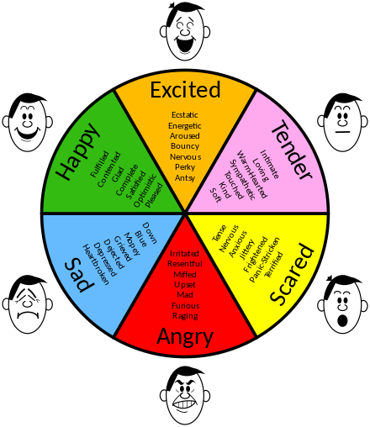

1. System Implementation
2. System Testing and Result Analysis
3. Conclusion